Test Case: tc002_SPX_Dev5_Crear_Requisicion_Spot_Tipo_Cobro_Project
Step 1 - Enter username and password and click to button Enter: Credentials Entered
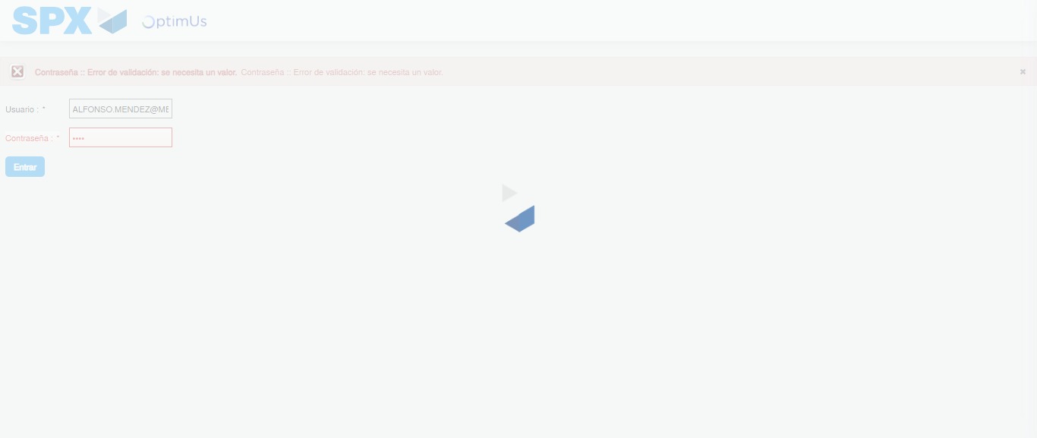Image file-name: QC_Testing-tc002_SPX_Dev5_Crear_Requisicion_Spot_Tipo_Cobro_Project-1784307392122

Step 2 - Select to UEN and Access to Spot Buy Requisitions : UEN Correctly selected and Correct access
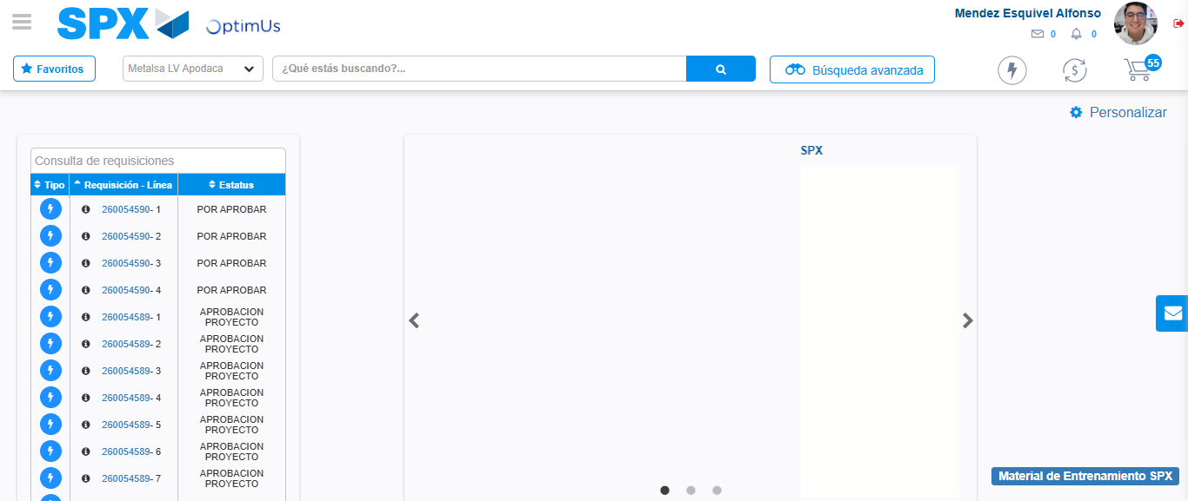Image file-name: QC_Testing-tc002_SPX_Dev5_Crear_Requisicion_Spot_Tipo_Cobro_Project-1784307461933

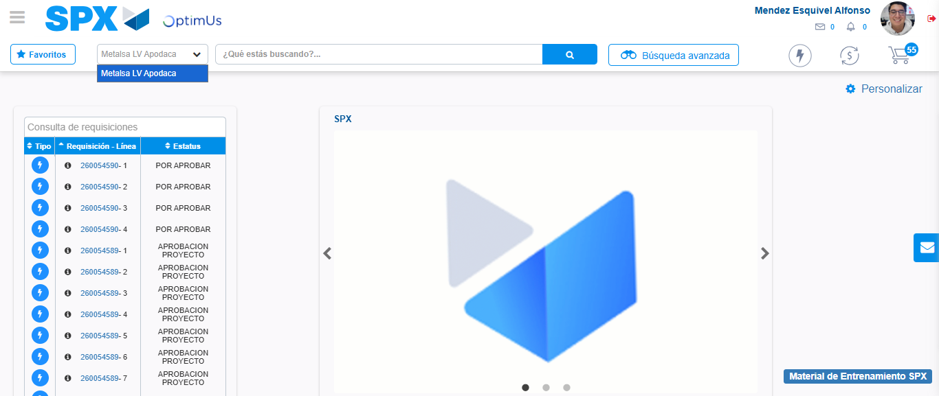Image file-name: QC_Testing-tc002_SPX_Dev5_Crear_Requisicion_Spot_Tipo_Cobro_Project-1784307464442

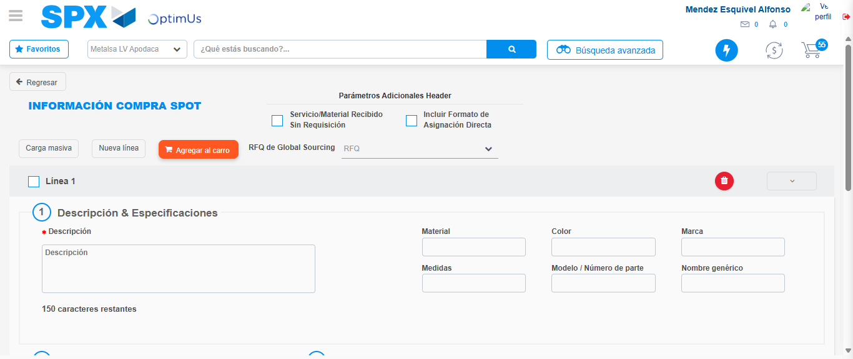Image file-name: QC_Testing-tc002_SPX_Dev5_Crear_Requisicion_Spot_Tipo_Cobro_Project-1784307502492

Step 3 - Data Capture Spot Buy Requisition: Data captured correctly
Image file-name: QC_Testing-tc002_SPX_Dev5_Crear_Requisicion_Spot_Tipo_Cobro_Project-1784307502724

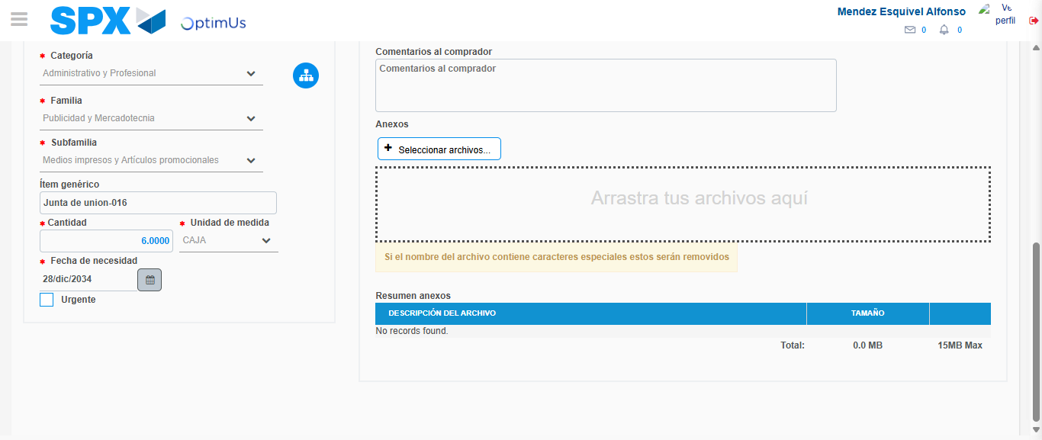Image file-name: QC_Testing-tc002_SPX_Dev5_Crear_Requisicion_Spot_Tipo_Cobro_Project-1784307513679

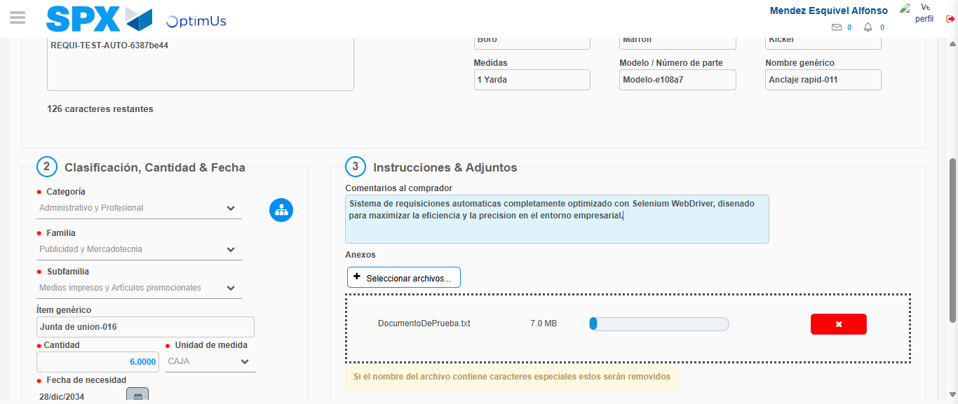Image file-name: QC_Testing-tc002_SPX_Dev5_Crear_Requisicion_Spot_Tipo_Cobro_Project-1784307514413

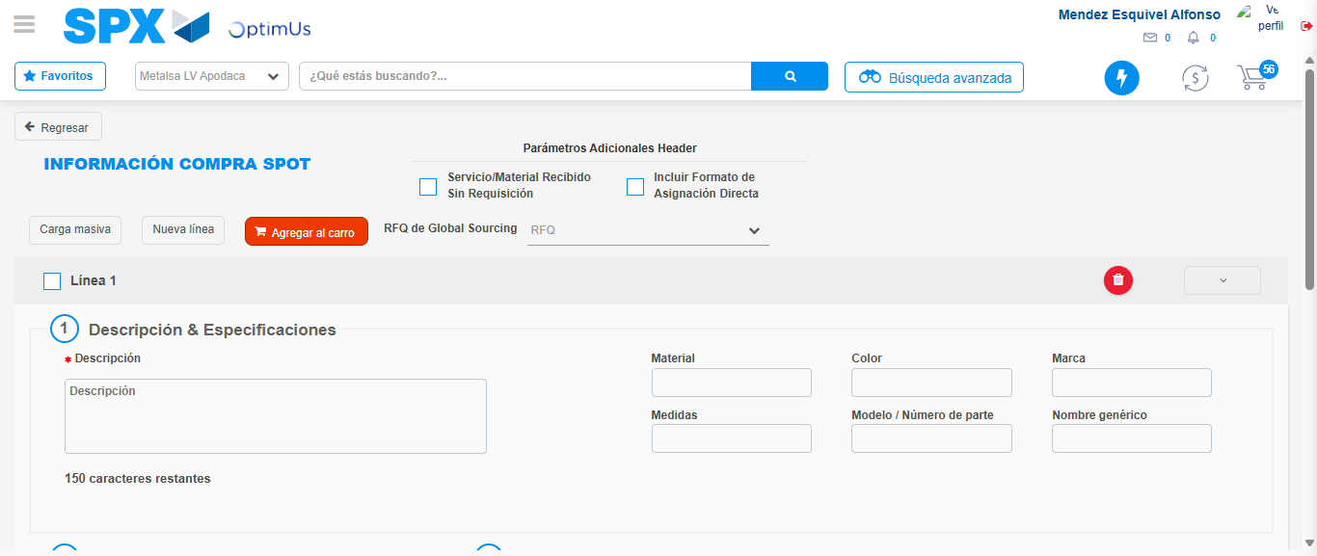Image file-name: QC_Testing-tc002_SPX_Dev5_Crear_Requisicion_Spot_Tipo_Cobro_Project-1784307521752

Step 7 - Return to Main Page SPX : Return to Main Page SPX
Image file-name: QC_Testing-tc002_SPX_Dev5_Crear_Requisicion_Spot_Tipo_Cobro_Project-1784307461933

Image file-name: QC_Testing-tc002_SPX_Dev5_Crear_Requisicion_Spot_Tipo_Cobro_Project-1784307464442

Image file-name: QC_Testing-tc002_SPX_Dev5_Crear_Requisicion_Spot_Tipo_Cobro_Project-1784307502492

Image file-name: QC_Testing-tc002_SPX_Dev5_Crear_Requisicion_Spot_Tipo_Cobro_Project-1784307523954

Image file-name: QC_Testing-tc002_SPX_Dev5_Crear_Requisicion_Spot_Tipo_Cobro_Project-1784307524152

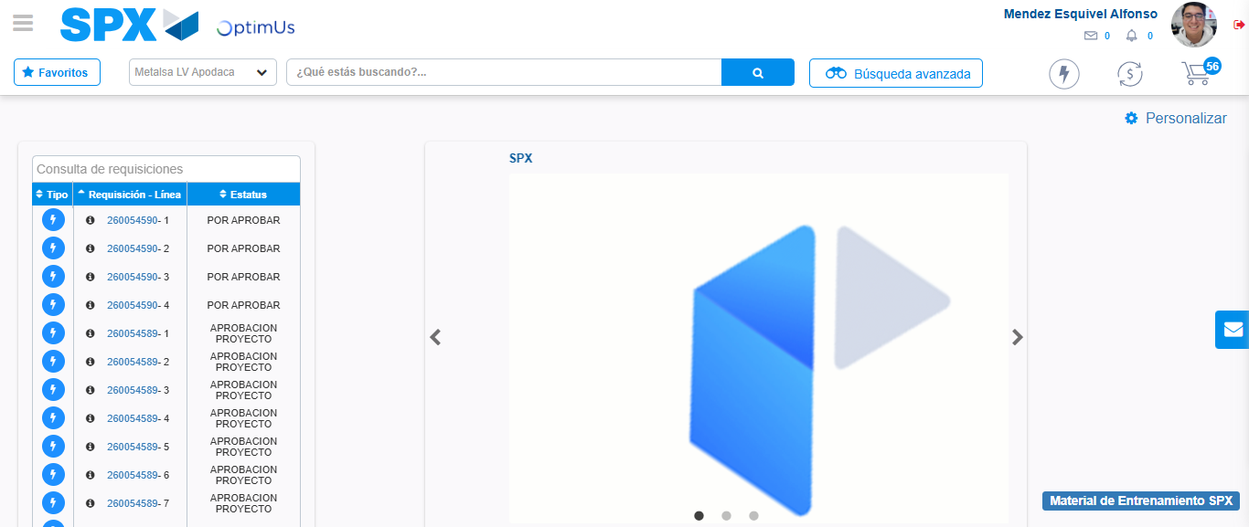Image file-name: QC_Testing-tc002_SPX_Dev5_Crear_Requisicion_Spot_Tipo_Cobro_Project-1784307545377

Step 8 - Log Out : Log Out SPX
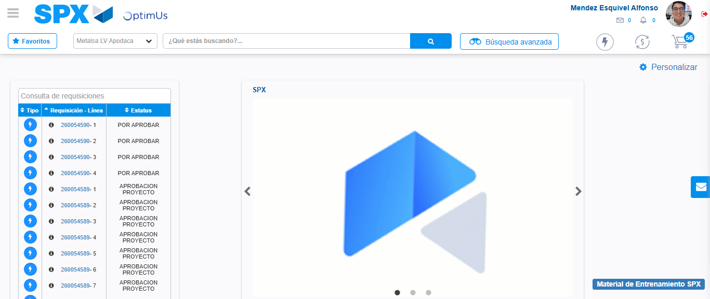Image file-name: QC_Testing-tc002_SPX_Dev5_Crear_Requisicion_Spot_Tipo_Cobro_Project-1784307545667

